**Effect of coral-giant clam artificial reef on coral recruitment: Insights for Restoration and Conservation Efforts**

Isis Guibert*, Róisín Hayden, Christine Sidobre, Gael Lecellier and Veronique Berteaux-Lecellier.

**Supplement S1 - Supplementary figures**

**Environmental Data**

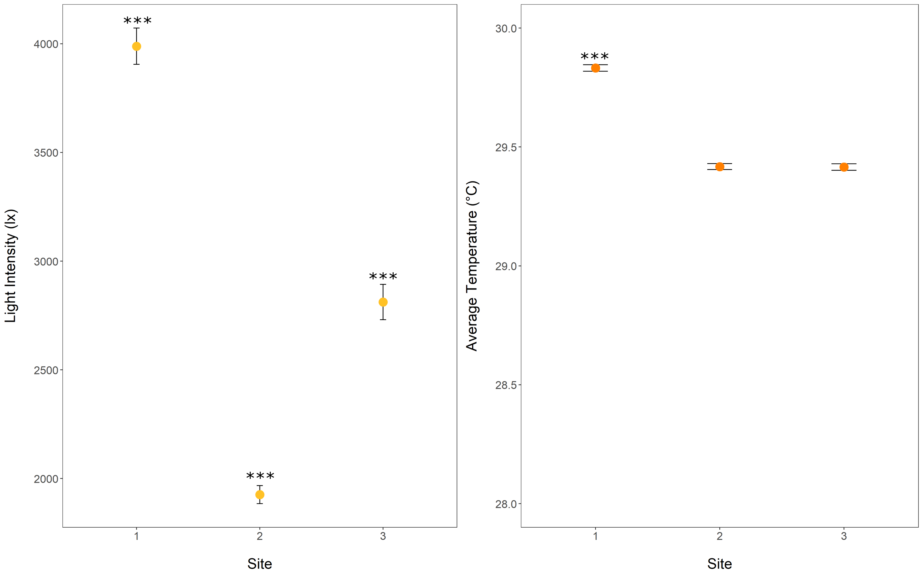

Figure S1: Average light intensity and temperature by sites. Statistically significant differences are indicated by stars, ***p<0.001.

Average light intensity at all sites was significantly different from all of the other sites (ANOVA, p<0.001) with site 1 having a significantly higher light intensity (3988.72 lx ± 83.37) compared to site 2 (1925 lx ± 41.63) and 3 (2811.96 lx ± 81.46). The average temperature at site 1 (29.83℃ ± 0.014) was significantly higher than site 2 (29.42℃ ± 0.013) and 3 (29.42℃ ± 0.014 ) (ANOVA, p<0.001, Supplement SX).

The observed recruitment variation, with site 1 having the highest recruitment followed by site 2 and then site 3, did not match the light intensity gradient observed ( Site 1 > Site 3 > Site 2), indicating that the light intensity was not the primary factor influencing coral recruitment in our study.

Temperature might have played a role in the important recruitment in site 1 compared to sites 2 and 3, but the mere 0.4 ℃ difference suggests that this factor did not have a significant impact on the recruitment. A previous study from Ritson-Williams et al. (2016)demonstrated that a temperature increase of 6 ℃ did not impact the survival and settlement of coral recruits.

**Recruits**

Figure S2: **Average number of coral recruits per site.** Lines represent standard error. PAT, P. acuta, A. cytherea, and T. maxima; AT, A. cytherea and T. maxima; PT, P. acuta and T. maxima; PA, P. acuta and A. cytherea; A, A. cytherea; P, P. acuta; T, T. maxima; and C, control. Statistically significant differences are indicated by stars, ***p<0.001.

References :

Ritson-Williams R, Ross C, Paul VJ (2016) Elevated temperature and allelopathy impact coral recruitment. PLoS ONE 11